1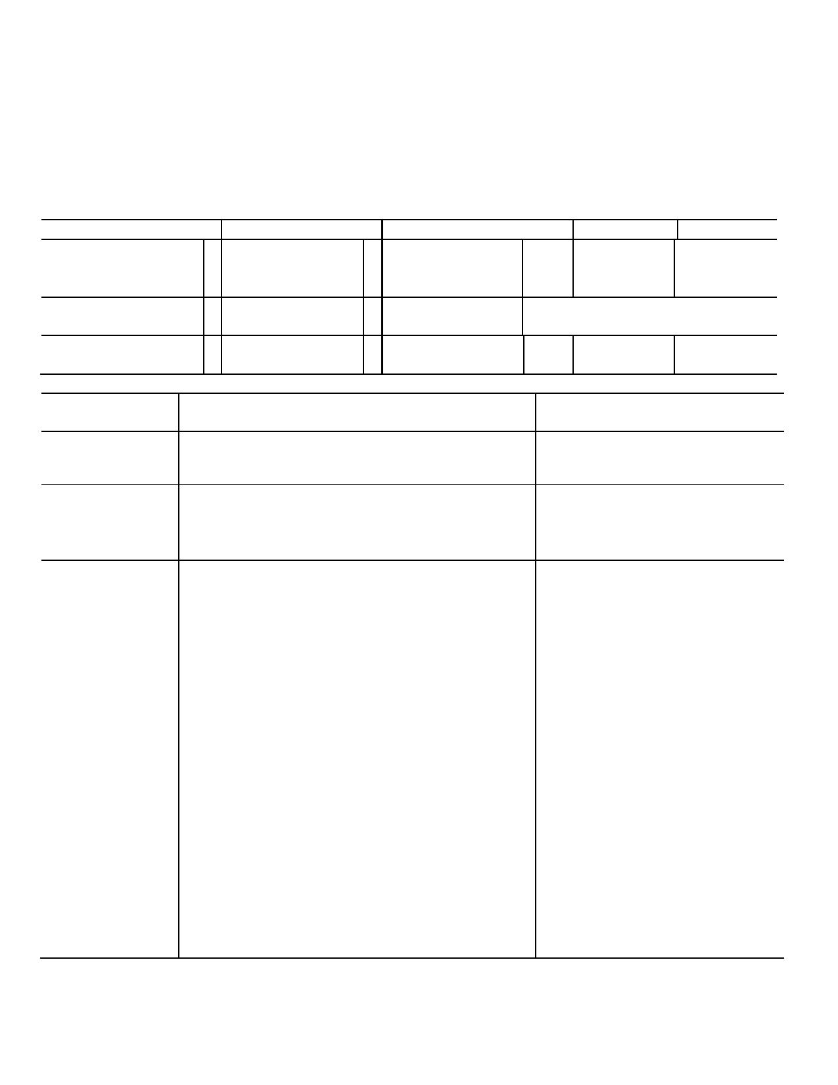

**EXECUTIVE COMMITTEE**

**MEETING MINUTES**

**MEETING DATE:**  **September 28, 2015 2:00 pm**

**LOCATION:**  Hawaii Hall 208

**ATTENDANCE:**  [P = Present; A = Absent; E = Excused]

**MEMBERS**  **MEMBERS**  **MEMBERS**  **GUESTS**  **TIME** Bob Cooney - Chair P Bonnyjean Manini P Jeff Kuhn P VP Young 3 - 4:40

VCAFO p.m.

Cutshaw

Marguerite Butler - P Ashley Maynard P John Kinder - P

Vice Chair Staff

Kelley Withy - SEC E Sarita Rai P

Secretary

**SUBJECT**  **CONTEXT**  **ACTION / STRATEGY /**

**RESPONSIBLE PERSON**

**CALL TO**  Meeting was called to order by

**ORDER**  Chair Bob Cooney at 2:07 pm

**REVIEW OF**  1. The minutes of September 21, 2015 SEC meeting 1. 1. Motion by M. Butler to

**MINUTES**

**CHAIR'S REPORT**

had been circulated electronically before the

meeting.

1. 5% tax on RTRF. This is an alteration to

operating budgets without consultation. There is

an objection to its use for lawsuits based on the

statute that set up RTRF. We are in a budget

crisis mode and we need to examine how RTRF

is spent. Equity is an issue.

2. R. Cooney attended the Student Fee Committee

(SFC). There was a request from SONDH to

increase the fee significantly for Dental

Hygiene (DH) students. Note that DH students

must also pay for specialty materials and

supplies. The net cost for a DH student is

approximately $20K/year. The Student Fee

Committee rejected the increase. Former

Chancellor Hinshaw created the SFC when she

implemented the Athletics Fee. Any fee

proposal goes through the SFC, which makes

recommendations to the chancellor. If the

proposal passes, it then goes to the president

and BOR.

approve the minutes as

amended; second by S. Rai.

Passed unanimously.

1. Refer to COR to look at how

RTRF is allocated and used.

2. No action taken.

**UNIVERSITY OF HAWAI'I AT MĀNOA FACULTY SENATE**

2500 Campus Road • Hawai'i Hall 208 • Honolulu, Hawai'i 96822

Phone: (808) 956-7725 • Fax/Polycom: (808) 956-9813

E-Mail: *uhmfs@hawaii.edu* • Website: *http://www.hawaii.edu/uhmfs/*

*An Equal Opportunity/Affirmative Action Institution*

2

**SUBJECT**  **CONTEXT**  **ACTION / STRATEGY /**

**RESPONSIBLE PERSON**

**ACTION**  1. CFS committee recommendations for SERG, 1. B. Manini moved to approve the

**ITEMS**  CPM, MAC, CSA, SCAB, GC, CAPP, and CFS recommendations, and M.

AGC were accepted. Another person is still Butler seconded. CFS

needed on MAC. recommendations were approved

unanimously.

**ADDITIONS TO**  1. There was discussion of reporting incidents of1. 1. SEC will continue to discuss

**THE AGENDA**  mismanagement to the campus. ways to do this. SEC will continue

to present at BOR meetings.

**GUESTS**  1. VP Young and VCAFO Cutshaw (2:55 pm). K. 1. SEC will continue to monitor

Cutshaw indicated that the Budget Task Force

of FY 2015 sent a report to the chancellor in

June 2015. The chancellor organized a small

committee this summer, led by Bill Chismar, to

finalize the report. Chismar's group sent a

report to the chancellor the week of September

21, 2015. There will be small-group meetings to

present the report. Eventually Maenette

Benham will lead a campus conversation about

the budget.

VP Young is not aware of specific Mānoa- System conversations about the budget.

Others outside the university are being told that we at Mānoa are working toward a system that

aligns teaching output with tuition dollars.

Guests were asked if they had confidence in the

process. Cutshaw said that the smaller group

(of deans) was to refine the recommendations

of the larger group. The small group is putting

forward a recommendation. The chancellor is looking at how to communicate these thoughts

to the community.

Cutshaw indicated that neither group had

requested data for the models to see what the

impacts would be. However, the SEC would

like to see models populated with data.

Cutshaw would like a model first, with numbers

populated later. As of September 28, 2015, the

faculty still has not seen a budget model.

the Mānoa budget situation and

to be involved in discussions.

**UNIVERSITY OF HAWAI'I AT MĀNOA FACULTY SENATE**

2500 Campus Road • Hawai'i Hall 208 • Honolulu, Hawai'i 96822

Phone: (808) 956-7725 • Fax/Polycom: (808) 956-9813

E-Mail: *uhmfs@hawaii.edu* • Website: *http://www.hawaii.edu/uhmfs/*

*An Equal Opportunity/Affirmative Action Institution*

3

**SUBJECT**  **CONTEXT**  **ACTION / STRATEGY /**

**RESPONSIBLE PERSON**

Existing G fund, Outreach, and RTRF "models" were left alone in the proposed model.

Cutshaw suggested that the SEC send a list of

questions and requests to the chancellor to help

him come up with a way to discuss this with the

campus.

Frustration was expressed that we should be discussing solutions.

Confidence is low now on the campus.

The model redistributes revenues, but it doesn't create more revenue.

Chair Cooney asked for more faculty

involvement in how decisions are made to

allocate funds. We may need to come up with a

solution to support units that don't pay for

themselves.

There is no clarity on the status of the hiring

freeze. All instructional faculty hires are subject

to the VCAA's approval.

When asked if someone is monitoring the

balance of the hires that the VCR recommends

and the VCAA recommends, Cutshaw said,

"No." She explained that each VC is responsible for his/her own budget.

Cutshaw and the SEC noted that there has been no substantive discussion of priorities.

Young: Report for FY 15 showed that revenues

came in short of what was anticipated. But

revenues were more than the previous year. On

the expenditure side, there was a greater amount

of under expending, vs. what was forecast for

expenditures. Spending was less than in FY 14.

Expenditures were constrained. This translated

to a plateau of the reserve spending.

**UNIVERSITY OF HAWAI'I AT MĀNOA FACULTY SENATE**

2500 Campus Road • Hawai'i Hall 208 • Honolulu, Hawai'i 96822

Phone: (808) 956-7725 • Fax/Polycom: (808) 956-9813

E-Mail: *uhmfs@hawaii.edu* • Website: *http://www.hawaii.edu/uhmfs/*

*An Equal Opportunity/Affirmative Action Institution*

4

**SUBJECT**  **CONTEXT**  **ACTION / STRATEGY /**

**RESPONSIBLE PERSON**

Young: 73% of our expenses are in personnel at

Mānoa. Enrollment is down and all the cost

drivers are all increasing or set to increase.

An SEC member noted, "Mānoa is the only

campus in trouble in the system. The flagship is

tanking, and everyone else is healthy. Where

does that come from and what are the

differences?" In response, Young said that

Mānoa is the most evolved and complex

because it has a myriad of programs. Mānoa has

larger loss leaders than other campuses.

By not hiring tenure-track faculty on regular

positions, and hiring lecturers, we are limiting

ourselves on future hires. We get less and less

support and this drives us toward bankruptcy as

well.

The VCAA did redistribute money across

academic units. Some units got an

"augmentation." Cutshaw was asked, "What

were the criteria?" She indicated that decisions

were under the jurisdiction of the respective

VC.

Young said that the perception right now is that UH, specifically Mānoa is not well managed. It

doesn't have a fiscal acuity about it. It's not

transparent.

On Mānoa campus, 100% of G-funds are used for salaries.

Positives: The UH System gets 30% of its operating budget ($1.1B) out of G-funds.

Roughly $400-412M is from G-funds.

Compared to other state institutions, that is high

state support. Since the fiscal crisis, as other

university systems have lost public funding, the

UH lost less, but there has been zero growth in

public funding.

**UNIVERSITY OF HAWAI'I AT MĀNOA FACULTY SENATE**

2500 Campus Road • Hawai'i Hall 208 • Honolulu, Hawai'i 96822

Phone: (808) 956-7725 • Fax/Polycom: (808) 956-9813

E-Mail: *uhmfs@hawaii.edu* • Website: *http://www.hawaii.edu/uhmfs/*

*An Equal Opportunity/Affirmative Action Institution*

5

**SUBJECT**  **CONTEXT**  **ACTION / STRATEGY /**

**RESPONSIBLE PERSON**

President Lassner is looking at efficiency of

operations across the System and Mānoa. He

will have a progress report on that at the

November board meeting.

**COMMITTEE**  1. CPM is meeting October 1 at 4 pm at HH 1. No action taken.

**REPORTS**  208.

2. Other committee reports were postponed to 2. No action taken.

the 10/5/15 meeting.

**OLD BUSINESS**  None 1.

**NEW**  None

**BUSINESS**

**ADJOURNMENT** The next meeting of the Senate Executive Motion to adjourn by M. Butler;

Committee will be October 5, 2015. seconded by S. Rai. All approved

the motion. Meeting adjourned at

5:45 pm.

Respectfully submitted by Ashley Maynard, Senate Secretary

Approved unanimously on October 5, 2015.

**UNIVERSITY OF HAWAI'I AT MĀNOA FACULTY SENATE**

2500 Campus Road • Hawai'i Hall 208 • Honolulu, Hawai'i 96822

Phone: (808) 956-7725 • Fax/Polycom: (808) 956-9813

E-Mail: *uhmfs@hawaii.edu* • Website: *http://www.hawaii.edu/uhmfs/*

*An Equal Opportunity/Affirmative Action Institution*